www.iteptravel.com
COMPANY PROFILE

Welcome to:

ITEP Travel

“Eco- responsable people”
Perú tour operador and designer of custom travel memories in Perú
www.iteptravel.com – www.perutravel.net
INTRODUCTION
ITEP EcoTravel
- COMPANY | ITEP EcoTravel
- TRADE NAME | Inka Trail Expeditions Perú
- MANAGER | William Escalante Taype
- E- MAIL | info@iteptravel.com  info@perutravel.net
- ADDRESS IN CUSCO | San Agustín 317 Street - Cusco
- ADDRESS IN LIMA | Shell N° 343 Street of: 201 – Miraflores -Lima
- PHONE NUMBER .CUSCO | +51 (084) 253617
- PHONE NUMBER -LIMA | +51 (01) 2422409
- WEB SITE | www.iteptravel.com – www.perutravel.net

ITEP EcoTravel
The best travel agent for business travel agents

Wellcome ITEP EcoTravel, the best Travel agency in Perú, we offer many trip options, vacation plans to explore the beauty of Perú and the Latin Passion. We offer the best deals on our tour packages, hotels, flights and train tickets, always offering our service with quality care.

System Access ITEP EcoTravel.
“Through our next system, you can download all our programs and net prices for travel agencies”

URL: agency.iteptravel.com
User: iteptravel
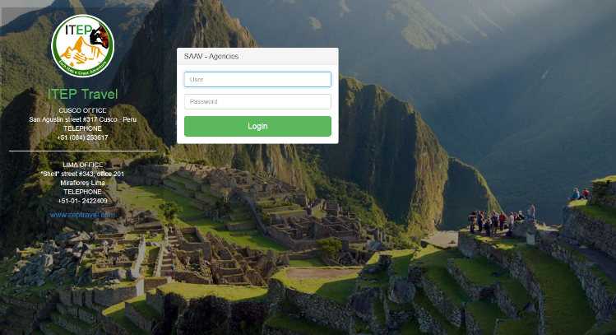
Password: iteptravel

Our Trips:
ITEP EcoTravel

1.- TAYLOR MADE TRIPS: We talk to you personally so often you need to explain and prepare all your travel details.

2.-CLASSIC TOURS BY DESTINY: Classic tours to all destinations of Peru by destiny, Cusco, MachuPicchu, Puno, Trujillo, with confirmed departure every day in a group service.

3.-TREKS IN PERÚ: For the outdoor adventurer, Peru holds within its boundaries a plethora of trails and treks. With a vast array of climates, land formations, rivers and jungles, Peru has something to suit the taste of nearly everyone with a grand sense of adventure.

4.-TOUR TO THE AMAZON: Tours to the Amazon Jungle, Jungle lodges; cruises in a natural paradise where everything is possible and where the adventures are limitless. The Amazon Rainforest is the basis of many options for tours and wildlife and traditions.

5.-BIRDWACHING: Peru is home of an extraordinary diversity of bird species ; even new species are discovered each year in the Amazon jungle , inaccessible mountain ranges and between the Andean valleys.Ornithologists have recorded 1730 species ( almost 20 % of the world total).

6.-COMUNNITARY TOURISM:
Experience local life, visit the real Perú! Local communities welcome you to their life, their traditions and their history. RESPONS offers the opportunity to experience the local Peruvian cultures in the mountains and jungle by providing accommodation with local families in native communities.
ITEP EcoTravel

7.- TOURIST CIRCUITS IN PERÚ: best Perú attractions in a complete tour circuit along the most beautiful and important places in Perú.
8.-TOURIST CIRCUITS IN PERÚ AND BOLIVIA: There are different tours that you can take with us in order to enjoy your visit in both countries in the same journey; Peru and Bolivia shares a common history.

9.-TOURIST CIRCUITS IN PERÚ, BOLIVIA AND CHILE: Immerse yourself in the culture and geography of the western countries of South America; Chile, Peru and Bolivia. All itineraries can be tailor made to fit into daily guaranteed departures.
10.-TOURS FOR STUDENTS “BUDGET”: Student Tours by our travel department. We offer budget student travel, guided student tours, weekend tours, day trips, etc.

Why with ITEP EcoTravel:
ITEP EcoTravel

- YEARS OF EXPERIENCE :
ITEP EcoTravel SINCE 2007 offer to our guests a wide variety of the best in affordable vacation packages, specifically tailored to reflect the interests of modern, mature travelers. We obtain excellent rates on airfare, hotels, sightseeing excursions, and cruise itineraries.
- CUSTUMER EXCELENCE SERVICE:
With almost 10 years’ experience, ITEP EcoTravel offers quality service for independent, family & corporate travelers. Our travel agency consultants provide personalized service, unbiased advice and excellent value to our travelers.
- QUALITY SERVICE STÁNDAR:
ITEP EcoTravel is working with our quality standard called GOLD:
- Great and Smile
- Own the Problem
- Look the part
- Delivery the wow
- 100% CONFIRMED DEPARTURE:
All our departure are confirmed with a minimum of 02 travelers.
- 24/7 SERVICE:
24/7TM after hour’s service provides an extension of your agency or corporate travel department’s daytime service, individually customized to perform a seamless service to your traveler’s emergency travel needs.
- EXCELLENTE NET RATES FOR TRAVEL AGENCYES:
ITEP EcoTravel
ITEP EcoTravel has their own hotel in Machupicchu www.hotel-encanto.com & own tourist transports which allows us to offer more competitive rates.
- PAYMENTS:
Payments from cities out our Perú are without bank commission.
- TAX EXEMPTION:
Through the promotion of foreign investment, all passengers arriving from abroad through our travel agency are exempt from tax.
- GOOD PRICES FOR TOUR LEADERS:
Tour leaders only pay entrance fees and transport cost such as fly, train tickets.
- SOCIAL PROJECTION: “THE INKA FUNDATION”
Our foundation supports orphanages , schools for children with special abilities , we support Andean communities so that they have a more direct relationship with the Department of Tourism of our country and they can have a much more professional and serious help from the Peruvian government.

- WINNING AWARD BY THE PERUVIAN CONGRESS
ITEP EcoTravel has been recognized with several distinguished awards, recently named as a prominent company in 2015 and 2016 by the Congress of the Republic of Peru.
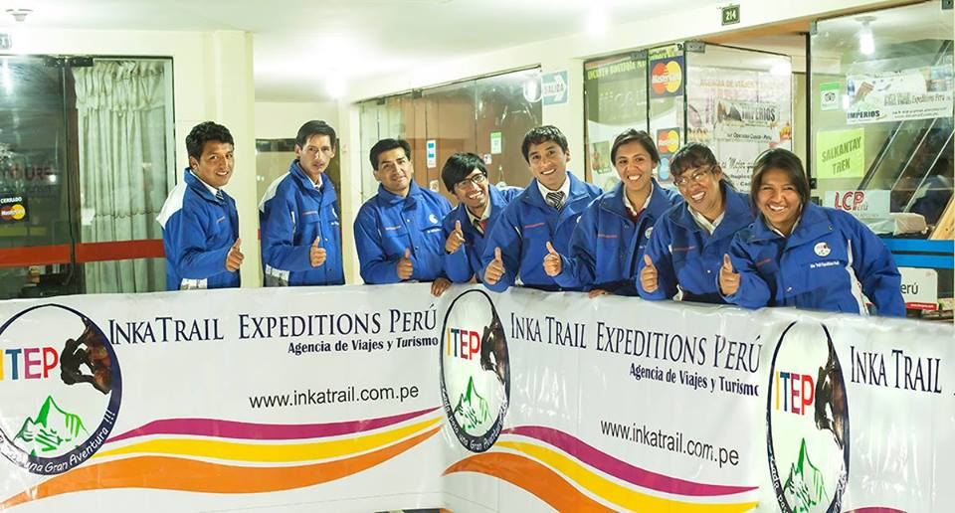
Our Team
ITEP EcoTravel

MISSION  We are an organization that provides travel services with quality standards GOLD.  We understand that friendship and details are the most memorable moments of our traveler’s experiences. | VIEW  Our vision is to be a leading tourist organization at national and international level to disseminate the importance of quality of service combined with social responsibility and environmental | VALUES  - Respect  - Punctuality  - Honesty  - Responsibility  - Quality of service  - Professional ethics  - Teamwork  - Competitiveness  - Commitment  - Eclectic character  - Empathy

DEPOSIT INFORMATION:
ITEP EcoTravel
Option 1: To pay through this option, just click in the following link:
http://www.iteptravel.com/payments/visa.php
Option 2: Paypal option: administration@inkatrail.com.pe
Option 3: Money gram or Western Union money transfer.
Destiny: Cusco - Perú
William Escalante Taype
ID: 42752119
Cellphone: +51-084-253617
Option 4: Bank transfer
Bank name: BANCO DEL CREDITO DEL PERU
Bank code: BCPLPEPL
Swift Códe: BCPLPEPL
Name: Inka Trail Expeditions Peru
Trade number: 20528015752
Account number (13 digits) US$: 285-2164353-1-47
Interbank code: 00228500216435314754
Adress: San Agustin Street 317
City: Cusco - Perú
Option 5: United Bank transfer
BANK NAME: First Century Bank
ACCOUNT TYPE: CHECKING
ACCOUNT #: 4012693248433
ABA#(Bank Routing Number):061120084
Nombre: Elvis William Bombilla Taype
Dirección: Urb. Lucrepata E-9 Cusco

Authorizations & Awards
ITEP EcoTravel

